**Interview**>**Requisições de Compras Pendentes**

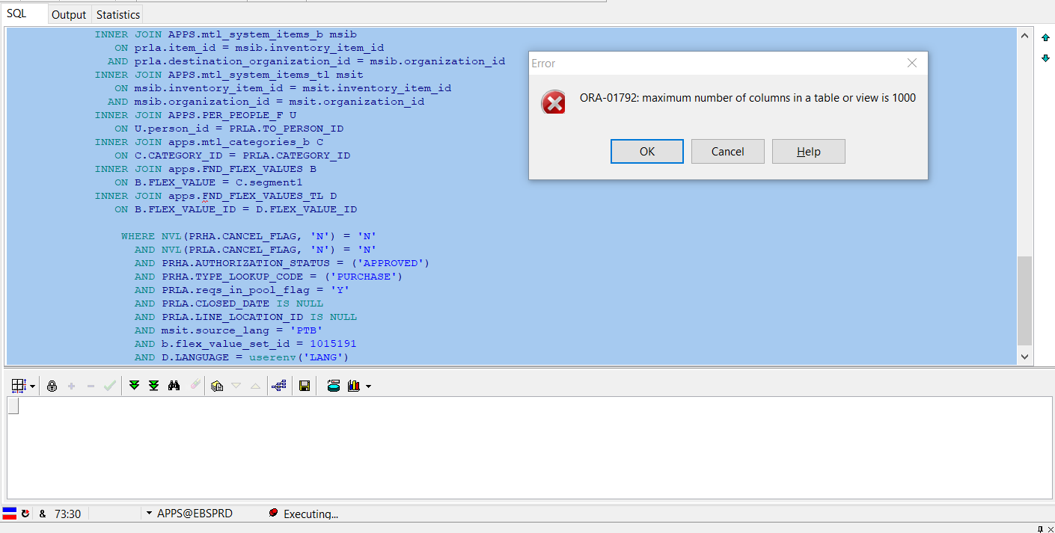

SELECT

distinct PRHA.SEGMENT1 NR_REQ,

PRLA.LINE_NUM NR_LINHA,

prda.distribution_num Linha_distribuicao,

msib.segment1 Codigo_Item,

decode(msib.inventory_item_flag,

'Y',

'Estoque',

'N',

'Despesa') Tipo_Item,

msib.description DESCRICAO_CURTA,

msit.long_description DESCR_ITEM,

msib.primary_uom_code "UDM",

prda.req_line_quantity QTDE,

DECODE(PRLA.URGENT_FLAG,

'N',

'Não',

'Y',

'Sim',

PRLA.URGENT_FLAG) AS URGENTE,

PRLA.REFERENCE_NUM AS NUM_REFERENCIA,

PRLA.NOTE_TO_AGENT AS AVISO_COMPRADOR,

DECODE(PRLA.DESTINATION_TYPE_CODE,

'SHOP FLOOR',

'Chão de Fábrica',

'EXPENSE',

'Despesa',

'INVENTORY',

'Inventário',

'RECEIVING',

'Recebimento',

PRLA.DESTINATION_TYPE_CODE) AS TIPO_DESTINO,

C.segment1 Grupo,

D.DESCRIPTION Descr_Grupo,

C.segment1 || '.' || C.segment2 GrupoSubgrupo,

U.full_name AS SOLICITANTE,

MP.ORGANIZATION_CODE ORG,

TRUNC(PRHA.APPROVED_DATE) DATA_APROVACAO,

papf.full_name COMPRADOR,

TRUNC(SYSDATE) - TRUNC(PRHA.APPROVED_DATE) DIAS,

GCC.SEGMENT1 || '.' || GCC.SEGMENT2 || '.' || GCC.SEGMENT3 || '.' ||

GCC.SEGMENT4 || '.' || GCC.SEGMENT5 || '.' || GCC.SEGMENT6 || '.' ||

GCC.SEGMENT7 AS CONTA_CONTABIL,

PRLA.UNIT_PRICE VALOR_UNITARIO

FROM APPS.PO_REQUISITION_LINES_ALL PRLA

INNER JOIN APPS.PO_REQUISITION_HEADERS_ALL PRHA

ON PRHA.REQUISITION_HEADER_ID = PRLA.REQUISITION_HEADER_ID

AND PRHA.ORG_ID = PRLA.ORG_ID

INNER JOIN APPS.PO_REQ_DISTRIBUTIONS_ALL PRDA

ON PRLA.REQUISITION_LINE_ID = PRDA.REQUISITION_LINE_ID

INNER JOIN APPS.GL_CODE_COMBINATIONS GCC

ON PRDA.CODE_COMBINATION_ID = GCC.CODE_COMBINATION_ID

INNER JOIN APPS.MTL_PARAMETERS MP

ON PRLA.DESTINATION_ORGANIZATION_ID = MP.ORGANIZATION_ID

LEFT JOIN APPS.PER_ALL_PEOPLE_F PAPF

ON PRLA.SUGGESTED_BUYER_ID = PAPF.PERSON_ID

INNER JOIN APPS.mtl_system_items_b msib

ON prla.item_id = msib.inventory_item_id

AND prla.destination_organization_id = msib.organization_id

INNER JOIN APPS.mtl_system_items_tl msit

ON msib.inventory_item_id = msit.inventory_item_id

AND msib.organization_id = msit.organization_id

INNER JOIN APPS.PER_PEOPLE_F U

ON U.person_id = PRLA.TO_PERSON_ID

INNER JOIN apps.mtl_categories_b C

ON C.CATEGORY_ID = PRLA.CATEGORY_ID

INNER JOIN apps.FND_FLEX_VALUES B

ON B.FLEX_VALUE = C.segment1

INNER JOIN apps.FND_FLEX_VALUES_TL D

ON B.FLEX_VALUE_ID = D.FLEX_VALUE_ID

WHERE NVL(PRHA.CANCEL_FLAG, 'N') = 'N'

AND NVL(PRLA.CANCEL_FLAG, 'N') = 'N'

AND PRHA.AUTHORIZATION_STATUS = ('APPROVED')

AND PRHA.TYPE_LOOKUP_CODE = ('PURCHASE')

AND PRLA.reqs_in_pool_flag = 'Y'

AND PRLA.CLOSED_DATE IS NULL

AND PRLA.LINE_LOCATION_ID IS NULL

AND msit.source_lang = 'PTB'

AND b.flex_value_set_id = 1015191

AND D.LANGUAGE = userenv('LANG')

and rownum =5;